Project 2

Multithreading

Varun Subramanya

Due 10/18/2018

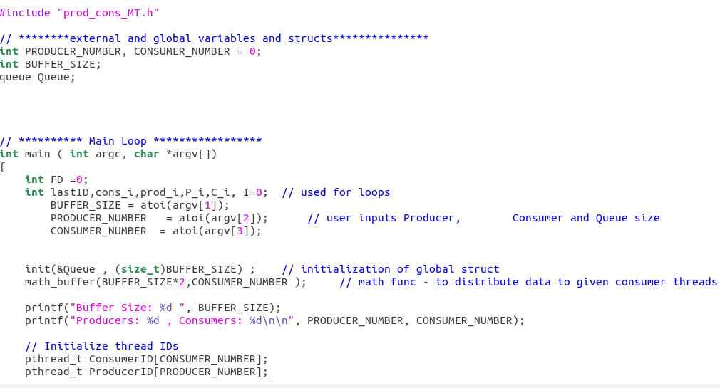

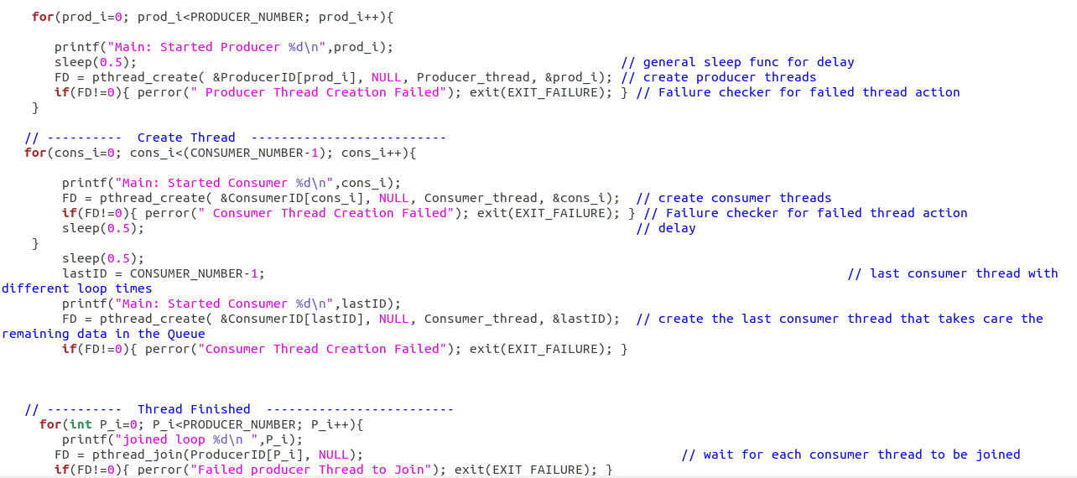

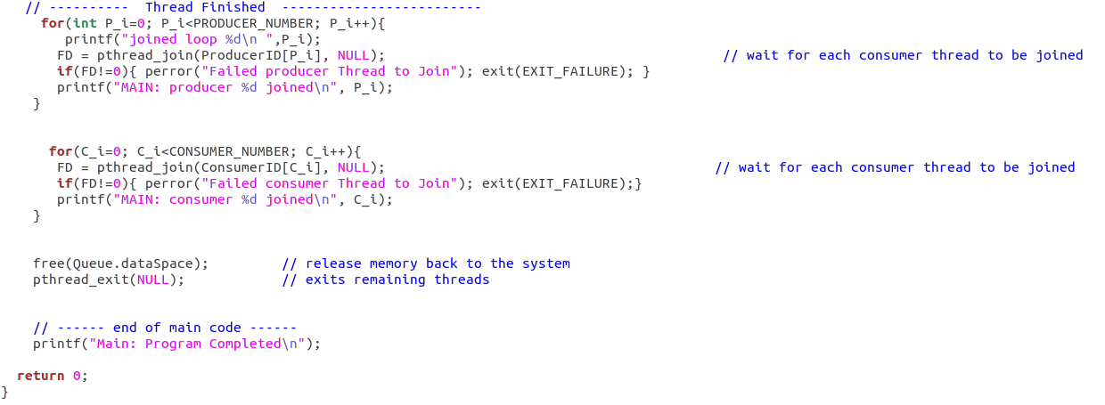

Fig: The main OS_Program2.c code

Pod_cons_MT.h

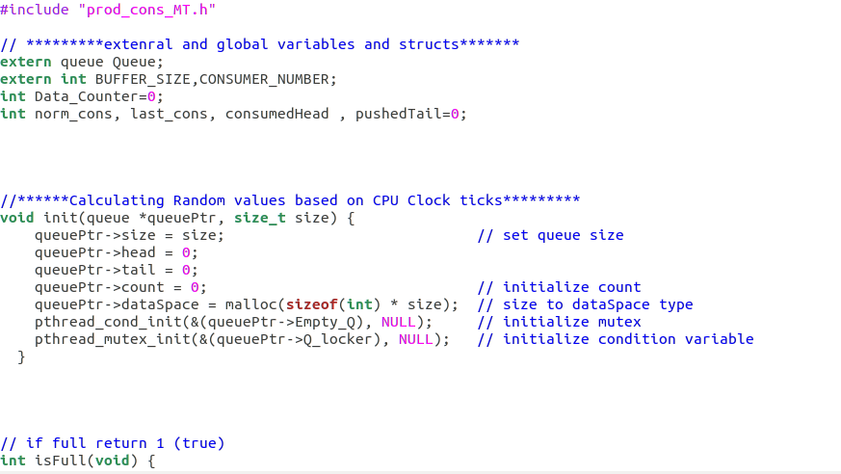

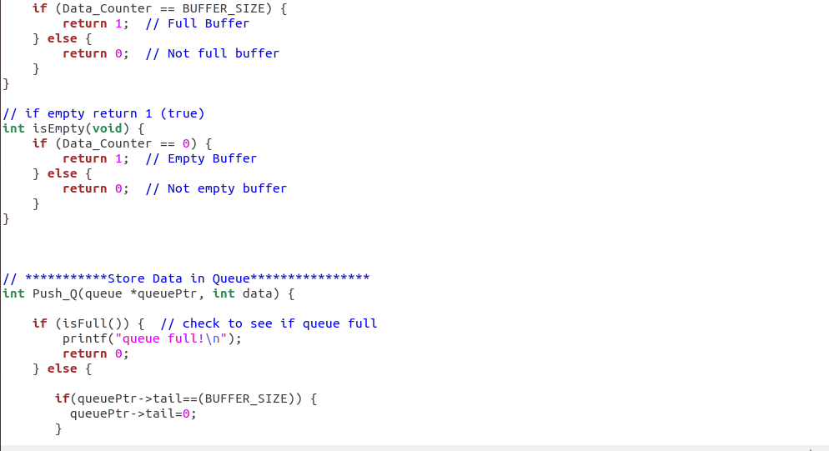

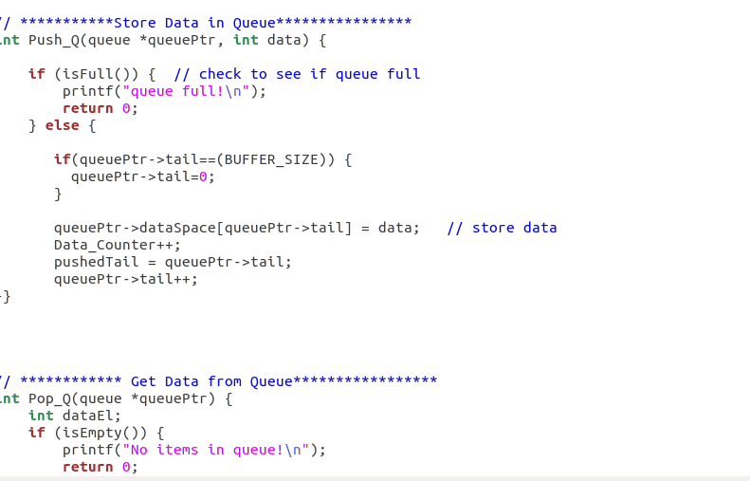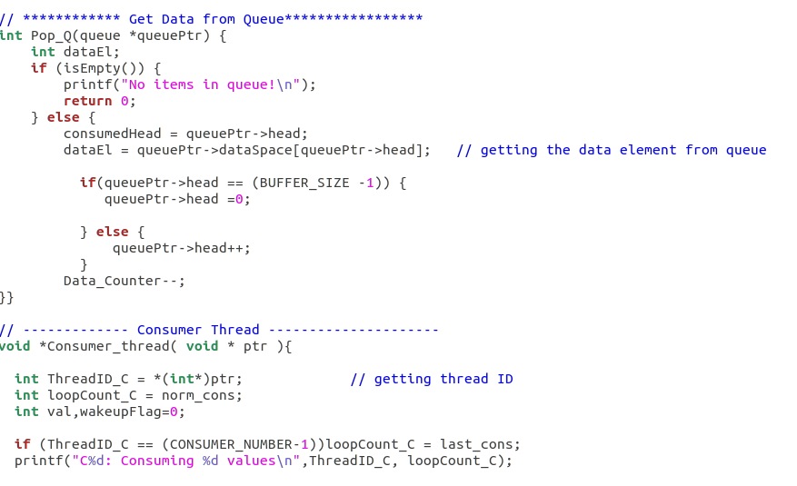

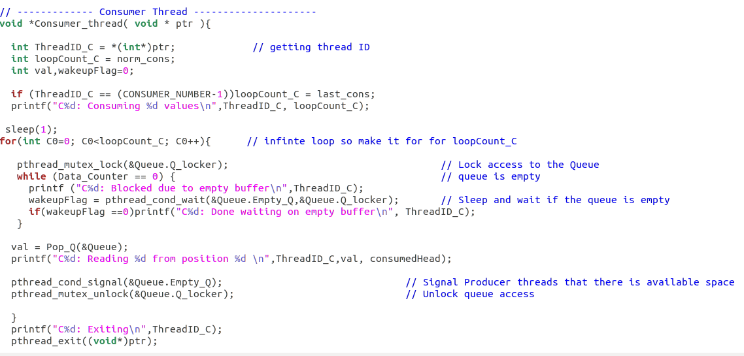

Fig: shows the code for prod_cons_MT.c where all the functions reside.

Header File:

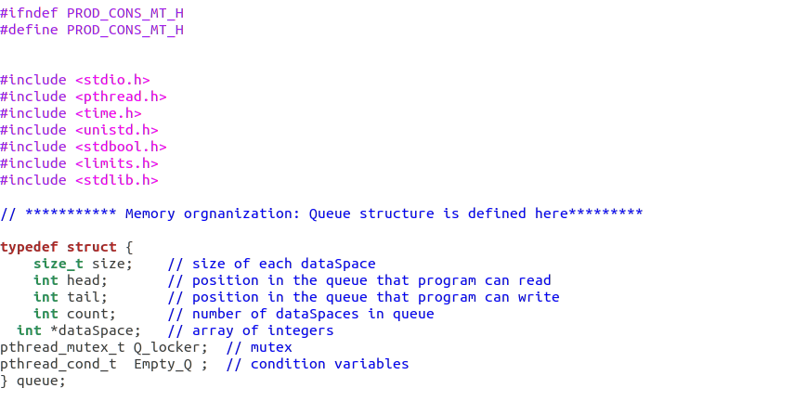

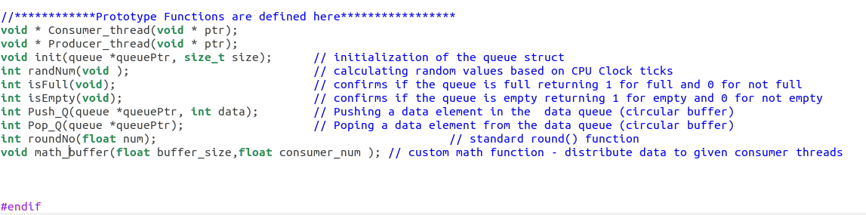

Fig: Header file prod_cons_MT.h

Screenshots:

1. Single buffer , single producer and single consumer

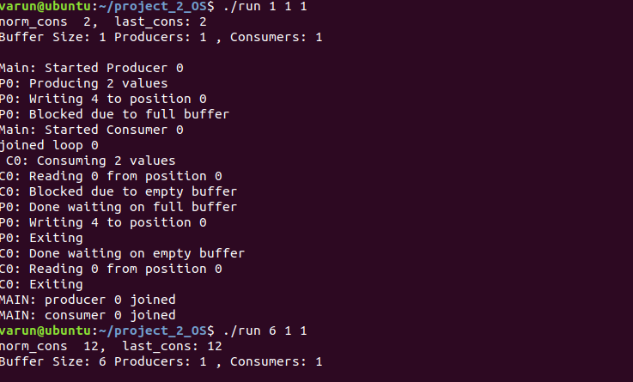

1. Increased buffer size, single producer and single consumer

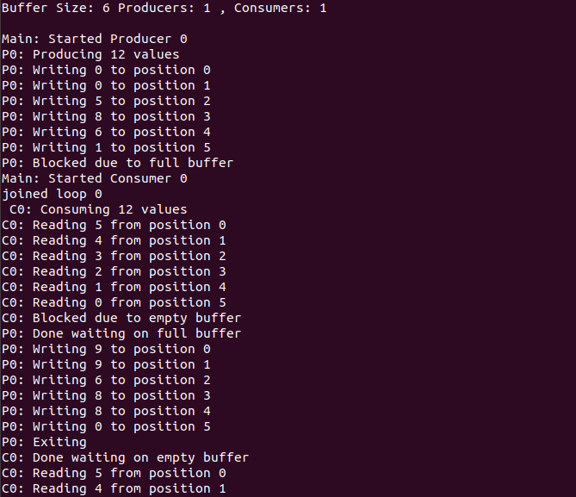



1. Buffer Size 4 , 2 producer and single consumer

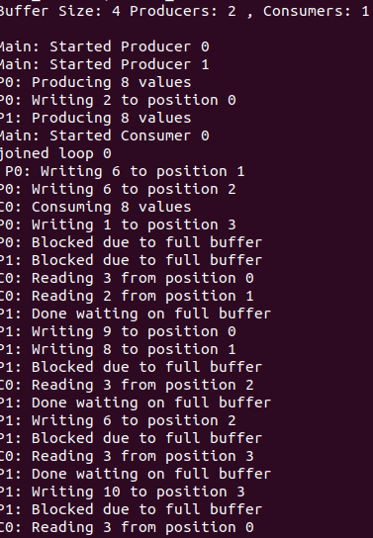

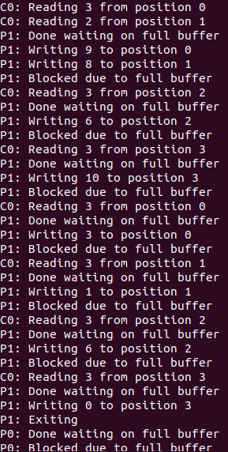

1. Buffer size of 4 2 producers and 3 consumers ( multiple produers and consumers)

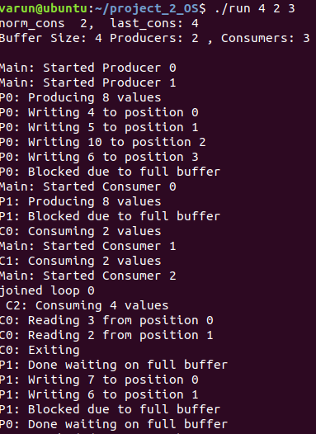

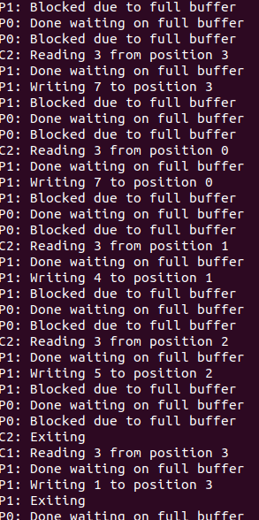

Note: The output of the program can be viewed by following the steps given in the readme file.